Environmental Studies Lab: Expansion
East Coast, USA
Codi Shine
Tech Report 2
Dr. Anumba
11/15/2013

Executive Summary
This technical report 3 was an alternative methods analysis. This report consisted of a project manager interview, critical industry issues and the feedback from the PACE Roundtable event.
The project manager interview was broken into two categories: Schedule Acceleration Scenarios and Value Engineering topics. The first topic discussed for schedule acceleration is critical path of the project. The critical path for this project was the site work, foundations, steel, exterior skin, roof, rough-in, permanent power and commissioning. The risks for the schedule were discussed and they include the exterior skin, permanent power and commissioning. The exterior skin was very intricate and there were a lot of questions about the air vapor barrier that required clarification and then coordination among the general contractor and subcontractors. The permanent power was delayed on the project which made the finishes be delayed. This is because the finishes would have started being installed in the middle of December which is when they would need heat instead of the cold weather. Since the Environmental Studies Lab: Expansion is a lab; it requires commissioning that is very stringent.
Value engineering was not used a lot on this project; however there were a few ideas that were not implemented. One idea was for the composite metal panels on certain parts of the façade to be replaced with a material that serves a function. The composite metal panels are there for aesthetics. Another idea was to get rid of the fall protection on the roof. This would be acceptable because the parapet would be raised to 42”. The fall protection penetrates the PVC roof which could cause leaks. By removing the fall protection, it removes these unnecessary penetrations.
At the PACE Roundtable event that the 5th year architectural engineering students attended along with industry professionals, there were two breakout sessions. These breakout sessions were designed to help the students generate research topics for their thesis project. The sessions attended were Assembling Effective Cross-Function Teams and Efficient Delivery of Facility Management Information, respectively.
Also at the PACE Roundtable event, the students received feedback for their research ideas. Daniel Buchta was one industry professional that I met with. We discussed possible topics such as a delivery model and design-bid-build vs. performance.
Contents
Schedule Acceleration Scenarios 2
Critical Path 2
Schedule Risks 2
Acceleration 4
Value Engineering 5
Exterior Skin 5
Fall Protection 5
Critical Industry Issues 6
Breakout Session 1- Assembling Effective Cross-Functional Teams 6
Breakout Session 2 – Efficient Delivery of Facility Management Information 7
Feedback from Industry Roundtable 9
Appendix A: Breakout Sessions 10
Appendix B: Feedback from an Industry member 12
Technical Report 3 Part 2 14
Executive Summary 15
Problem Identification and Technical Analysis Option 15
Problem 1 – Delivery Method 15
Problem 2 - Intricate Façade 15
Problem 3 – Short Interval Production Schedule (SIPS) 16
Problem 4 – BIM Implementation 16
Problem 5 – Air Vapor Barrier Installation 17

Schedule Acceleration Scenarios

Critical Path
The critical path for The Environmental Studies Lab: Expansion seems to be every primary part of the building. The critical path is shown in Figure 1. The site work for the building goes on throughout the entire project. The geothermal wells and the geothermal vaults were what started the site work. The foundations and geothermal wells were being completed simultaneously. There was a delay because of weather during the foundations. Since the foundations were in the critical path, this delayed the project three months. The steel is in the critical path because it is the above grade structure. The exterior skin and roof were in the critical path because it was important to get the building enclosed before winter so the rough-in and permanent power could be in the building. Commissioning for a lab takes a lot of time because of how rigorous it was.
Figure 1 Critical path

Schedule Risks
There are always many different risks on any project that hinder it from being completed on time. There are a few that pertain directly to The Environmental Studies Lab: Expansion. One of the biggest risks for completing the project on time was the complexity of the exterior skin. The façade was made up of many different materials, but it was what was behind it that was complex. This system consisted of a 4” insulated metal panels, 6” cold form metal framing and then metal studs. At the top and bottom of the 6” cold form metal framing was steel tubing. It was discovered that the air vapor barrier (AVB) that was shown in the drawings, did not provide a true AVB. There was also confusion on where the location of the AVB should be. Through all the coordination meetings and requests for information, it was finally decided that the AVB should be located on the inside face of the 4” insulated metal panel and continue over the steel tube. The coordination meeting was between the architect, general contractor, and all the subcontractors involved. They established a method for developing the proper AVB and decided it should be a blue skin, which is a water proof membrane, to act as the AVB. This is shown in Figure 2. 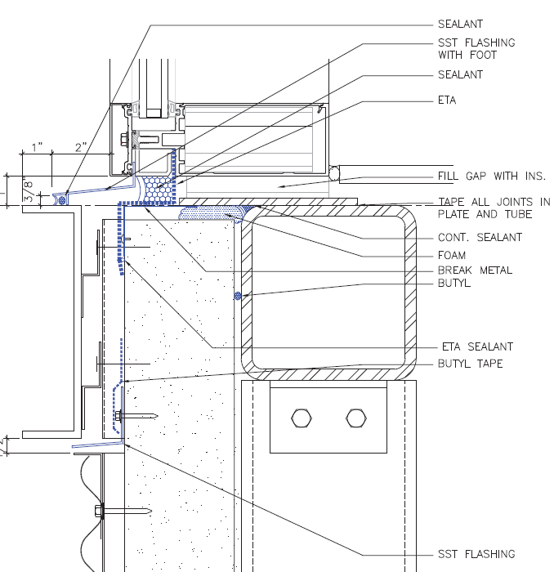
Figure 2 AVB Solution
Figure 2 AVB Solution
Another schedule risk that occurred on this project was getting permanent power set up. Since the project was delayed already by this time, there was a rush to get permanent power set up in the building. The permanent power meant temporary heating in the building. This would then mean that the finishes could be started. Permanent power was supposed to be running by December, however this did not happen and the project was delayed. Temporary heaters had to be used which cost more money.
The Environmental Studies Lab: Expansion is a laboratory. That being said, commissioning for a lab is more stringent. This is because there is a lot of equipment that has to be inspected and tested. Since the building is LEED Platinum, there is a higher performance expectancy for the MEP system.

Acceleration
In order to counteract these risks, there were some acceleration techniques that could have been applied to help finish on time. Sometimes a job requires there to be work completed on Saturdays or during later hours. However, this overtime is not preferred. Instead of overtime, increase the manpower.
Since the exterior skin was a big risk, a way to accelerate the schedule is to have more crews. If there were more crews on for each trade involved in the skin, it would get done a lot faster. To ensure that these crews would not get in each other’s way, the work could be sequenced differently. The south face and the north face could be completed simultaneously. With more crews, there could be workers from each trade on either side of the building.
Another possible acceleration is changing the delivery method to integrated project delivery (IPD). This would have to have been done at the start of the project. With this delivery method, it would have allowed for collaboration between the owner, architect and general contractor. The general contractor would have been able to have some input on the design. This could have reduced problems that occurred on the project such as the AVB issue on the exterior skin. Another delivery method option would be design build. TALK ABOUT DESIGN BUILD

Value Engineering
The Environmental Studies Lab: Expansion was a design-bid-build and there was not much value engineering. However, there were a few items that could be considered value engineering. In the specifications, there were specified materials that were switched out for non-specified materials. This was because it was better to keep the same manufacturer or the material cost less while keeping the same quality.
In the atrium, there are low hanging “ameba” lights. These lights are roughly a hundred thousand dollars each. There could have been lights purchased for cheaper that serves the same function, however these lights are for aesthetic purposes.

Exterior Skin
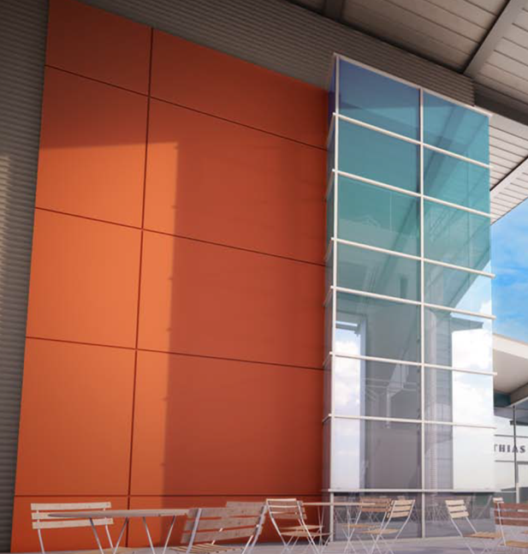
There were a few ideas to value engineer the exterior skin. Since there were 47 different types of material, it would be efficient to limit the number of subcontractors. This would mean finding subcontractors that manage multiple materials. It is efficient not to have so many subcontractors because they would be in each other’s way, there would be more contracts, and there may be more cost involved. Another value engineering idea dealing with the skin, that was not implemented, was the composite metal panels, Figure 3. Underneath of the panels was an insulated metal panel that is water tight. However, the panel itself does not serve a function. Its purpose is for aesthetics. It was very costly and it could have been substituted for something more cost effective.
Figure 3 Composite Metal Panels

Fall Protection
The fall protection that is on the roof could also have been value engineered. The roof is a PVC roof with a parapet. A suggestion to value engineer the roof was to remove the fall protection and raise the parapet. If the parapet was raised to 42”, the fall protection would not have been needed. Along with not needing fall protection, there wouldn’t be a need for the steel work or life safety. One of the bigger issues that would have been prevented if there was no fall protection, was there would be no penetrations in the PVC roof. With the fall protection, the PVC penetrations would be filled so the roof would not leak, however, that is not always guaranteed. It is better to make any penetrations in any material. The cost to raise the parapet is a larger cost, but it is cheaper in the long run because of the aforementioned issues. It was decided to leave the parapet at its current height and keep the fall protection for aesthetic purposes.

Critical Industry Issues
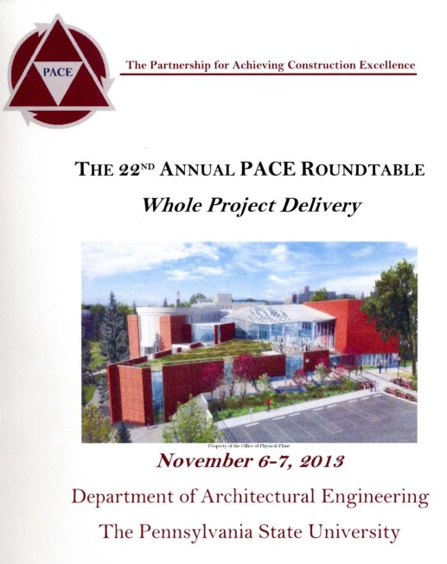
This year’s 22nd annual PACE (The Partnership for Achieving Construction Excellence) roundtable event was held on November 7, 2013, Figure 4. A mix of industry professionals, Penn State faculty, architectural engineering (AE) graduate students and 5th year AE students attended the roundtable event. This year’s topic was “Whole Project Delivery.” The meeting started out with an update on PACE and new items relating to the AE department. After that, the first break out session occurred followed by a presentation by a guest speaker. After lunch there was another break out session and then a focus group session where the students met with an industry professional to discuss research ideas.
Figure 4 PACE

Breakout Session 1- Assembling Effective Cross-Functional Teams
The first breakout session was led by Bryan Franz and Gretchen Macht. The session began with the group brainstorming what they thought made an effective team. The five most important terms they came up with were: collaborative, communication, common goal, leadership and trust. These were terms they thought make for a successful team and project. The cross-functional team part of the session was about the relationship and communication between the owner, architect and general contractor. Figure 5 shows this relationship. The red circle in the middle symbolizes the integration to accomplish goals. This requires personal interaction which is a big issue in today’s industry.

Owner

Architect

General
Contractor

Figure 5 Relationship of a cross-functional team
The group continued to discuss what situations this would work in. It depends on the contract type. It also depends on the owner. They can select the best value contractor, which means the low and competent contractor. From there, if the owner knows what they want, they can press that on the contractor. The contractor will then select the subcontractors based on what the owner wants. The contractor wants a company they have worked with before and someone they can trust so that would be how they want to pick their subcontractors. The owner can apply incentives to both the contractors and the subcontractors to get the job done faster. This entire method of selection still depends on the type of contract.
One interesting topic that was discussed was how to approach a “problem child” or a subcontractor that is not performing up to par. The general contractor can get rid of a subcontractor; however, that is not the smartest move. They have been on the project the entire time, so to bring a new company in may mess things up or cause a delay in the project. Instead of getting rid of the subcontractor, the general contractor may have to just work through it and ignore them. Both of those options do not sound ideal. In order to manage a “problem child,” there may need to be some collaboration and communication between the general contractor and that subcontractor. Someone higher up in the company may also have to be involved so there can be some sort of resolution.
There were a few good ideas that could be further researched that were suggested in this breakout session. The success of procurement in a certain area or on a certain type of building was one idea. This would require checking historical records and speaking to the owner and/or general contractor. Another idea would be to talk to the owner, the general contractor and the subcontractor in order to see what their goal is for that project. They should all have a common goal for the project.

Breakout Session 2 – Efficient Delivery of Facility Management Information
This breakout session was led by Ed Gannon and Craig Dubler. This discussion was about the efficient and inefficient aspects of the delivery of facility management information. There are a few different areas of facility management: asset management, space management, BAS/ controls, renovations, energy and engineering.
The first thing that needs to be done is to define the owner and understand their needs. This way the facility management information can go to the correct person and they can handle future issues correctly. The main reason for facility management information is for long term maintenance. This would be the total cost of ownership which is: initial cost, cost of maintenance, cost to replace and cost of repairs. Value engineering also considers the long term maintenance.
One thing that was touched on was facility management and technology. Technology is advancing but not everybody has been educated on how to use the technology. From an owner’s standpoint, technology of facility management is useful. However, the maintenance staff may prefer to use paper over BIM. In order for this to be successful, there should be meetings to educate everybody on the systems and how they work.
Future areas to be further researched were discussed in this breakout session. The life cycle of asset input and the use of the information were brought up because there could be a lot of information, but how much of it is actually going to be looked at in the future? Another research area would be an energy audit and energy savings. This is a very good idea for any building because there is always room for improvement when it comes to energy savings.

Feedback from Industry Roundtable
Industry member- Daniel Buchta (Barton Malow)
At the end of the PACE Roundtable Event, the students broke out into groups with industry professionals. I was in a group with Daniel Buchta, a project director from Barton Malow. We discussed research topics that I could possibly use on my thesis. One research topic was a delivery model. A way to approach this would be to look at an early procurement and a collaborative environment. This would help to find solutions to different problems that could arise and the contractor would have influence on the design. Another idea was to look at different delivery methods. Design-bid-build is not ideal because there is not much that can be changed without change orders. Other delivery methods can have the contractor influence rather than just the architect. To expand on this idea, there was the option to evaluate design-bid-build vs. performance. Bryan Franz is doing research on this topic.

Appendix A: Breakout Sessions

Session 1: 1-C Assembling Effective Cross Functional Teams

- Gather historical data from similar buildings and buildings from a similar area and analyze the success of procurement. This would all depend on owner’s permission.

- Talk to different people on the owner’s side, contractors and subcontractors to see levels of common goals. If they have similar goals, that can determine the success or failure of the project.

Session 2: 2-B Efficient Delivery of Facility Management Information

- Asset the energy savings of the LEED Platinum building.

- How much of the information given to the owner of the facility management is actually utilized or needed.

Appendix B: Feedback from an Industry member

Industry Member: Daniel Buchta – Barton Malow
Key Feedback:
- Design-Construction cost vs. Life cycle
- Delivery model- early procurement = collaborative environment
  - Find solution to problems
  - Influence design
- Design-bid-build vs. Performance
  - Hard-bid is difficult

Suggested Resources:
      - Bryan Franz – research on performance and delivery methods
      - Chuck Tomasco – electrical research
      - Andy Rhodes – mechanical research
      - Dave Hutt – project manager

Technical Report 3 Part 2

Executive Summary
The problems identified in this section will result in analyses. Analysis one is an in depth research of an alternative delivery method. Analysis two and three is a façade study and a look into Short Interval Production Schedule (SIPS), respectively. The final analysis will be on BIM and how to apply it to facility management. There will be an architectural breadth and a mechanical breadth that link into the façade study.

Problem Identification and Technical Analysis Option

Problem 1 – Delivery Method
The current delivery method, design bid build, is not the ideal delivery method. With this delivery method, coordination and communication were not handled in the best manner that they could have been. With a different delivery method, this could have been prevented.
A better delivery method would be design build. The general contractor and the designer are in a joint venture. This means both of these parties will be in the same area making it easier to communicate with everybody. The general contractor is also involved earlier in the project. They can assist with the design phase by foreseeing any problems that may arise. It helps accelerate the schedule because it is faster than design bid build. This method eliminates the bidding process. It also is faster because the project can be started without the design fully finished. Design build is a more cost effective method than design bid build because the designers have access to the construction cost as the project moves along. This could open up the possibility for value engineering.

Problem 2 - Intricate Façade
The façade is very intricate with many different materials. The main façade materials are: brick veneer, corrugated metal panels, composite metal panels, fiber cement siding, and a curtain wall system. All these different materials mean multiple subcontractors. With multiple subcontractors, there are more contracts and more people to coordinate with. Also, the trades would be stacked on each other which could hinder productivity and quality. There are also a few materials that are very expensive.
There could have been different materials and possibly less materials put into place. Less material means fewer subcontractors. This material may also be more cost effective. The architect will have to be contacted in order to determine what their intent was for the façade. This way there could be a similar approach taken in the research development.
Through this problem and analysis, there could be an architectural breadth and a mechanical breadth. The architectural breadth could concern a different material or design that is more cost efficient as well as serving a purpose. The composite metal panels are for aesthetics and they are expensive. I could look into a more cost effective material that also has a function. This would bring on a mechanical breadth. The mechanical breadth could look at how the new façade performs in different conditions such as rain or wind.

Problem 3 – Short Interval Production Schedule (SIPS)
SIPS is a very detailed form of scheduling that helps with efficiency out in the field. Each activity is assigned a duration that may be so precise it is down to the minute. It is critical to have good communication between all parties involved to avoid delays throughout each activity. Initially, there is a learning curve on the process. This will be there until the field workers familiarize themselves with the process.
Since SIPS helps with efficiency, this will accelerate the schedule. There are 18 large labs in the Environmental Studies Lab: Expansion. These labs have the same layout and items in it. There are a few different options on which trades could have a SIPS. The casework trade, the finishes trades, or the MEP trades are all options for those labs. The MEP overhead rough-in would be very useful to have a SIPS.

Problem 4 – BIM Implementation
On the Environmental Studies Lab: Expansion, there was not a lot of Building Information Modeling (BIM) implementation. There were a few problems that could have been prevented if BIM was used. BIM has many uses; it can be used for 3D coordination, site utilization planning and analysis, structural analysis, digital fabrication, and facilities management.
A big issue on the project was coordination between subcontractors. Since a clash detection was not run, there were a lot of clashes between the MEP work. Most of the issues were between the duct work and the fire protection. 3D coordination could have solved this problem before the construction even started.
BIM could have also been implemented at the end of the project for facilities management. Since this is a lab, there is a lot of complex equipment and processes that need to be maintained properly. With BIM, the maintenance personal could easily locate and understand how to proceed with the equipment that has an issue. This process could be very helpful in the long run to prevent costly measures to fix an issue.

Problem 5 – Air Vapor Barrier Installation
An issue that caused a lot of confusion on the project was the air vapor barrier in the exterior skin. This exterior skin consists of 4” insulated metal panels, 6” cold form metal framing and then metal studs. The 6” cold form metal framing is sitting between steel tubing. The issue with the drawings was that the air vapor barrier (AVB) did not provide a true AVB. There were multiple request for information (RFI) written concerning this issue. The first RFI concerned where the AVB should be placed. It was decided that it should be located on the inside face of the 4” insulated panel and continue over the steel tube. After that issue was resolved, the architect, the general contractor, and the subcontractors that were involved met to coordinate the proper method of developing the AVB, Figure 1. It was decided that there was going to be a blue skin, which is a water proof membrane, to act as an AVB.
In order to prevent this confusion, there could have been a virtual mockup of the wall. This would have helped foresee any problems that could have occurred during construction.
Figure 1 AVB Solution

